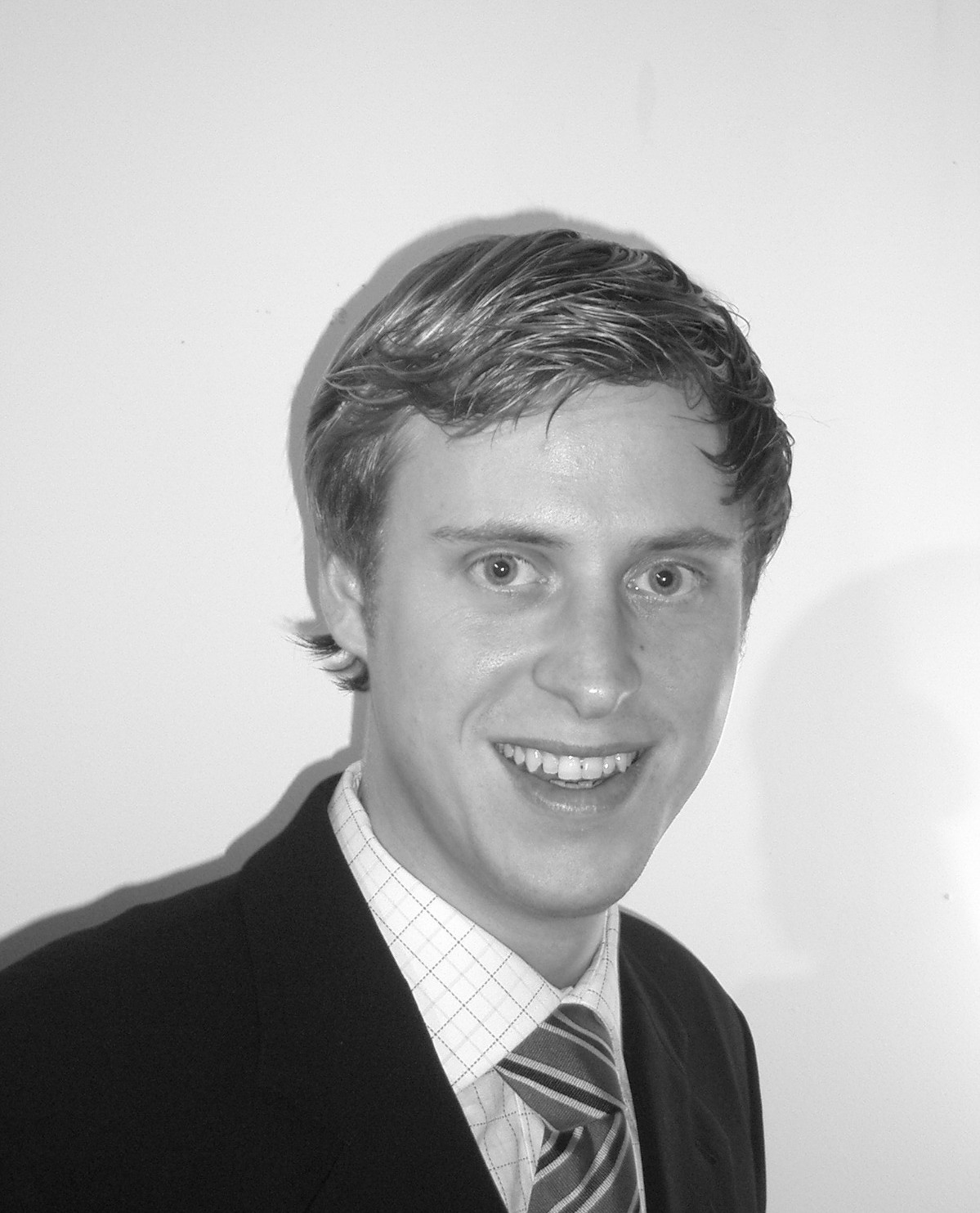
Alexander von Gosztony
Born 07th of May 1980 in Madrid

Hansastr. 24
44137 Dortmund
Germany

0049- 163 2548797
0049- 231 9125352
alexander.vongosztony@ism-dortmund.de

Education

2002-2006 International School of Management (ISM) Dortmund (Germany) International Business Administration
Preliminary Diploma International Management
Anticipated Graduation Date: July 2006
March 2004-June 2004 European Business School (EBS) Madrid
Madrid (Spain) First semester abroad
International Business Administration
1994-2001 “Georg- Willhelm- Steller” Gymnasium (High School)
Bad Windsheim (Germany) “Abitur”: German school-leaving examination and university entrance qualification
1991-1994 “Deutsche Schule Madrid” DSM Madrid (Spain) German school in Madrid

Work Experience

July 2004-August 2004 “Terra Bauer S.L.” Engineering firm
Madrid (Spain) Internship in the controlling & accounts department

July 2003-August 2003 “LHP Lehmann Hahn & Partner” Tax Consultant & Accountant
Uffenheim (Germany) Internship in tax accountancy and elaboration of the annual statement of account
for a big superstore chain

April 2002-June 2000 “Fa. Hahn KG“ Event & Catering Service
Bad Windsheim (Germany) Internship in the administration and the accounting department

July 2001-April 2002 “Arbeiter-Samariter-Bund“ (Similar to Red Cross)
Bad Windsheim (Germany) Civilian service

1996-2002 “Fa. Hahn KG” Event & Catering Service
Bad Windsheim (Germany) Frequently worked in the administration, the marketing department and the buying department

Language Skills

German Mother tongue
Spanish Mother tongue
English Fluent (11 years of instruction; 3 times 3 weeks of language courses in England)
French Medium knowledge (5 years of instruction)

IT- Skills

Languages HTML (basic); Visual Basic (basic)
Operating system MS Windows
Applications MS Office (Word; Access; Excel; Outlook; Power Point); MS photo editor; ERP (basic); SPSS (basic) and DATEV programmes (accounting program)

Initiatives & Volunteer University Activities

- Member of the student council
- Member of “PolitISM” (organisation of political debates and of political excursions)
- Participation in several workshops, presentation & excursions
- Certificate (ISM) for participation in & commitment to university projects
- Member of “JU, Junge Union e.V.”

